Project Title
PaperCheck: A Multi-Algorithm Approach to Research Paper Similarity Detection
Project Report submitted for the partial fulfilment of grade for the course

Data Structures and Algorithms -3 (25CS2103E)
in

A.Y. 2026-2027

Submitted by
Raghava Akkinepally – 2520030271
Janumpally Hansika – 2520030060
Nalajala Rishika Chowdary – 2520030212

Team Number: 8
Section: 7

Under the guidance of

<<Dr. S Madhavi>>

<<Designation, Department>>
Hyderabad-500090, Telangana, India.

K L (Deemed to be) University
DEPARTMENT OF COMPUTER SCIENCE ENGINEERING / COMPUTER SCIENCE AND INFORMATION TECHNOLOGY/ARTIFICIAL INTELLIGENCE & DATA SCIENCE



DECLARATION

The Mini Project Report entitled “PaperCheck: A Multi-Algorithm Approach to Research Paper Similarity Detection” is a record of Bonafide work of Raghava Akkinepally – 2520030271,Janumpally Hansika – 2520030060, Nalajala Rishika Chowdary - 2520030212. submitted in partial fulfillment for the award of B. Tech in Computer Science and Engineering/Computer Science and Information Technology/ Artifical Intelligence & data Science to the K L University. The results embodied in this report have not been copied from any other departments/University/Institute.

Raghava Akkinepally – 2520030271
Janumpally Hansika – 2520030060
Nalajala Rishika Chowdary - 2520030212

K L (Deemed to be) University
DEPARTMENT OF COMPUTER SCIENCE ENGINEERING / COMPUTER SCIENCE AND INFORMATION TECHNOLOGY
CERTIFICATE

This is to certify that the mini project based report entitled “PaperCheck: A Multi-Algorithm Approach to Research Paper Similarity Detection” is a bonafide work done and submitted by Raghava Akkinepally – 2520030271,Janumpally Hansika – 2520030060, Nalajala Rishika Chowdary - 2520030212. in partial fulfillment of the requirements for the award of the degree of BACHELOR OF TECHNOLOGY in Department of Computer Science Engineering/ Computer Science and Information Technology/Artificial Intelligence & Data Science, K L (Deemed to be University), during the academic year 2026-2027.

Signature of the Supervisor

Signature of the HOD Signature of the External Examiner

ACKNOWLEDGEMENT

The success in this project would not have been possible but for the timely help and guidance rendered by many people. Our wish to express my sincere thanks to all those who has assisted us in one way or the other for the completion of my project.

Our greatest appreciation to my guide, << Dr. S Madhavi >>, <<Designation>>, <CSE>> which cannot be expressed in words for his/her tremendous support, encouragement and guidance for this project.

We express our gratitude to Dr. P.Venkateshwar Rao (CSE) Head of the Department for Computer Science Engineering/ Department for Computer Science and Information Technology/Department of Artificial Intelligence and Data Science for providing us with adequate facilities, ways and means by which we are able to complete this project-based Lab.

We thank all the members of teaching and non-teaching staff members, and also who have assisted me directly or indirectly for successful completion of this project. Finally, I sincerely thank my parents, friends and classmates for their kind help and cooperation during my work.

Raghava Akkinepally – 2520030271
Janumpally Hansika – 2520030060
Nalajala Rishika Chowdary - 2520030212

TABLE OF CONTENTS

S.No. | Contents | Page no.
1. | Abstract
2. | Introduction
3. | Literature survey
4. | Problem Statement and Objectives
5. | Hardware and Software requirements
6. | Implementation
7. | Results & Discussion
8. | Conclusion & Future Scope
9. | References

1.ABSTRACT
The increasing availability of digital research papers has made plagiarism detection an important aspect of academic integrity. Manually comparing research papers with multiple reference documents is a time-consuming process. To address this problem, PaperCheck – Plagiarism Detection System Using Rolling Hash Techniques is developed as a web-based application that identifies textual similarities between an uploaded research paper and a collection of reference research papers.
The system allows users to upload research papers in PDF format through a user-friendly web interface. The backend extracts readable text from the uploaded document and performs preprocessing to normalize the content. The processed text is divided into consecutive groups of eight words, called K-grams, for efficient comparison. Rolling Hash and Rabin–Karp pattern-matching algorithms are used as the core techniques to generate fingerprints and identify candidate matching text sequences across the available reference documents.
The application is developed using React and Vite for the frontend and Node.js with Express.js for the backend. Multer is used for handling PDF uploads, and pdf-parse is used for text extraction. Additional algorithms, including Levenshtein distance, Damerau–Levenshtein distance, Needleman–Wunsch, and Smith–Waterman, are implemented for text-similarity analysis where integrated into the processing workflow. Other hashing, graph, optimization, and randomized algorithms are included as separate modules to demonstrate Data Structures and Algorithms concepts.
The system returns analysis information such as similarity values, extracted-word counts, and matching reference-paper details. The results help users identify possible textual overlap and examine the corresponding sources. The effectiveness of the system depends on the quality of text extraction, the available reference dataset, and the implemented matching and scoring methods.
Keywords: Plagiarism Detection, Rolling Hash, Rabin–Karp Algorithm, K-Grams, Dynamic Programming, Research Papers, Data Structures and Algorithms.

Team Members:
- Raghava Akkinepally – 2520030271
- Janumpally Hansika – 2520030060
- Nalajala Rishika Chowdary - 2520030212

2. INTRODUCTION

2.1 Background
In the present digital era, research papers, journals, conference publications, and academic documents are widely available in electronic formats. Students, researchers, and academic professionals frequently refer to existing research to gain knowledge, develop new ideas, and improve their work. However, using previously published content without proper acknowledgement can lead to plagiarism, which is a major concern in academic and research environments.
Plagiarism detection is the process of identifying similarities between a submitted document and existing sources. Manually comparing a research paper with numerous reference documents requires considerable time and effort. As the number and size of digital documents increase, an automated approach becomes necessary to make document comparison more efficient.
PaperCheck – Plagiarism Detection System Using Rolling Hash Techniques is a web-based application designed to identify possible textual similarities between an uploaded research paper and a collection of reference research papers. The project applies concepts from Data Structures and Algorithms (DSA) to develop an automated document-comparison system.
2.2 Overview of the Project
PaperCheck provides a simple interface through which users can upload research papers in PDF format and initiate similarity analysis. The uploaded document is processed by the backend, where readable text is extracted and normalized before comparison.
The extracted text is divided into consecutive groups of eight words, known as K-grams. These groups are used to generate fingerprints through the Rolling Hash technique. The Rabin–Karp pattern-matching algorithm then uses these fingerprints to identify candidate matching sequences between the submitted document and the reference papers.
The system processes the available reference documents and returns analysis information, including similarity values and matching document details. These results help users identify possible overlap and investigate the corresponding sources.
The frontend is developed using React and Vite, while the backend uses Node.js and Express.js. Multer handles file uploads, and pdf-parse extracts readable text from PDF documents.
In addition to the main matching algorithms, the project includes implementations of dynamic-programming, graph, optimization, hashing, and randomized algorithms to demonstrate different concepts from the DSA curriculum.
2.3 Motivation
The primary motivation behind PaperCheck is to apply theoretical knowledge of data structures and algorithms to a practical problem in academic research.
Manual plagiarism checking becomes difficult when a document must be compared against a large collection of research papers. Searching for repeated phrases in each document can be repetitive and time-consuming. An automated system can assist by identifying candidate matching sequences and organizing the results for further review.
The project also provides an opportunity to understand how algorithmic techniques can be integrated into a complete software application. It combines frontend development, backend programming, PDF processing, text preprocessing, algorithm design, and result presentation in a single workflow.
Another important motivation is to make the algorithmic implementation accessible for academic evaluation. The project maintains separate algorithm modules so that their functionality can be examined and demonstrated independently.
2.4 Problem Background
A research paper may contain text that resembles content from previously published documents. Identifying such overlap requires a method for comparing text sequences efficiently.
A straightforward approach would compare every possible sequence in the submitted document against every sequence in every reference document. This can involve a large number of repeated comparisons, particularly when the documents are long.
Hashing provides a way to represent text sequences using numerical fingerprints. Rolling Hash makes it possible to update fingerprints as a window moves through a document, while Rabin–Karp uses the fingerprints to identify candidate matching sequences.
These techniques form the algorithmic foundation of PaperCheck. Since different text sequences can occasionally produce the same hash value, candidate matches should be verified against the original text before being treated as confirmed matches.
2.5 Objectives of the Project
The main objectives of PaperCheck are:
- To develop a web-based application for research-paper similarity analysis.
- To provide an interface for uploading PDF documents.
- To extract readable text from supported PDF files.
- To preprocess and normalize extracted text before comparison.
- To divide text into consecutive eight-word K-grams.
- To implement Rolling Hash for efficient fingerprint generation.
- To implement Rabin–Karp for candidate pattern matching.
- To compare uploaded documents with the available reference-paper dataset.
- To present similarity information and matching-document details.
- To implement additional DSA algorithms in modular, reusable files.
- To test the application and its algorithmic components.
- To establish a foundation for future enhancements to document comparison.
2.6 Scope of the Project
The project focuses on comparing an uploaded research paper with a locally maintained collection of reference research papers. It includes PDF upload handling, text extraction, preprocessing, K-gram generation, hash-based matching, and presentation of analysis results.
The current implementation is designed primarily for PDFs from which readable text can be extracted. Image-only or scanned documents may require optical character recognition (OCR), which is a possible future enhancement.
The system does not automatically search every publication available on the internet. Its results depend on the reference documents present in the configured dataset and the matching methods implemented in the backend.
The additional DSA modules provide algorithmic demonstrations. Only algorithms actually invoked by the analysis service should be considered contributors to the final similarity calculation.
2.7 Significance of the Project
PaperCheck demonstrates the practical application of algorithm design in document processing. It illustrates how hashing and pattern matching can support the identification of repeated text sequences and how separate software components can be combined into a working application.
The project also develops practical skills in JavaScript programming, React-based interface development, backend API design, file handling, modular programming, testing, and version control.
Furthermore, the application can serve as a foundation for future research into more advanced document-comparison methods, including passage highlighting, OCR-based extraction, improved similarity scoring, and semantic text analysis.
2.8 Organization of the Report
This report is organized into chapters covering the introduction, literature survey, problem statement and objectives, hardware and software requirements, implementation, results and discussion, conclusion, future scope, and references.
The implementation chapter explains the architecture, processing workflow, and algorithmic components. The results chapter presents the application's actual outputs and testing observations. The final chapters discuss the project's limitations and possible improvements.

3.LITERATURE SURVEY
3.1 Introduction
A literature survey is an important part of software development and research because it helps understand existing systems, algorithms, and techniques related to the proposed project. It provides information about current approaches, their advantages, limitations, and the need for further improvement.
Plagiarism detection has become an important application of text processing and information retrieval. Existing approaches use exact text matching, document fingerprinting, string similarity, and semantic analysis to identify possible similarities between documents.
The literature survey for PaperCheck – Plagiarism Detection System Using Rolling Hash Techniques focuses on existing plagiarism detection tools and the algorithmic techniques relevant to the development of the proposed system.
3.2 Existing Plagiarism Detection Systems
3.2.1 Turnitin
Turnitin is a widely used academic similarity-checking platform that helps educational institutions identify matching text in student assignments and research documents. It generates similarity reports that allow users to examine matching passages and their sources.
Turnitin demonstrates the importance of presenting detailed matching information instead of relying only on a single similarity percentage. The context of each match must be examined to determine whether it represents an appropriate quotation, a citation, common terminology, or possible plagiarism.
Relevance to PaperCheck: PaperCheck follows the general approach of comparing submitted documents with reference sources and displaying possible matches. Unlike a large commercial platform, the current project uses a locally maintained dataset.
3.2.2 Grammarly Plagiarism Checker
Grammarly provides writing assistance and plagiarism-checking functionality. Its plagiarism-checking features help users identify text similarities while working on written content.
The integration of similarity checking into a writing workflow demonstrates how automated text analysis can assist users during document preparation.
Relevance to PaperCheck: The project similarly provides a user-friendly interface for submitting a document and viewing analysis results. However, PaperCheck focuses on demonstrating DSA algorithms rather than providing a complete writing-assistance platform.
3.2.3 Copyscape
Copyscape is a plagiarism detection service commonly associated with identifying duplicate content on the web. It helps users find instances where online content may have been reproduced elsewhere.
Its general approach illustrates the importance of comparing submitted text against relevant source material.
Relevance to PaperCheck: PaperCheck applies a related document-comparison concept but operates on a configured collection of local research-paper PDFs rather than claiming internet-wide source coverage.
3.2.4 Plagiarism Checker X
Plagiarism Checker X is a document-comparison tool designed to identify similarities between documents and reference material. It demonstrates the usefulness of automated text comparison in academic and professional environments.
Relevance to PaperCheck: Both systems aim to help users locate similar text. PaperCheck differs in its implementation approach, using JavaScript-based services and explicit algorithm modules for academic demonstration.
3.3 Literature on Rolling Hash
Rolling Hash is a technique used to calculate fingerprints for consecutive windows of text or other data. Rather than recalculating each window's hash independently, the algorithm updates the fingerprint as the window moves.
This property makes Rolling Hash useful for processing long sequences where many overlapping windows must be examined. Its efficiency depends on the hash formulation, window size, and implementation.
However, a hash value cannot uniquely represent every possible input. Different sequences may produce the same fingerprint, creating a hash collision. Therefore, applications should verify the original text when a candidate match is found.
Application in PaperCheck: Rolling Hash is used to generate fingerprints for consecutive groups of eight words. These fingerprints support the identification of candidate matching sequences between the submitted document and the reference papers.
3.4 Literature on Rabin–Karp Pattern Matching
Rabin–Karp is a pattern-matching algorithm that uses hash values to search for a pattern within a larger sequence. It compares fingerprints to identify candidate matches and can verify the corresponding text to confirm a match.
The technique is particularly suitable for searching for repeated sequences within long documents. Its expected efficiency depends on hash distribution and the number of candidate matches that require verification.
Application in PaperCheck: Rabin–Karp works with Rolling Hash to identify candidate matching K-grams. This combination forms the core of the exact text-matching approach used by the project.
3.5 Literature on Dynamic Programming for Text Similarity
Dynamic programming is a method for solving problems by dividing them into smaller subproblems and storing intermediate results. It is widely used in string comparison and sequence alignment.
3.5.1 Levenshtein Distance
Levenshtein distance calculates the minimum number of insertions, deletions, and substitutions needed to transform one string into another. It provides a quantitative measure of the difference between two strings.
In text analysis, this method can help identify small changes in wording or spelling. However, it does not by itself determine whether two passages constitute plagiarism.
3.5.2 Damerau–Levenshtein Distance
Damerau–Levenshtein distance extends the ordinary edit-distance approach by including adjacent character transposition as an operation.
This method can handle certain typographical changes more naturally than ordinary Levenshtein distance.
3.5.3 Needleman–Wunsch Algorithm
Needleman–Wunsch is a global sequence-alignment algorithm. It compares two complete sequences by optimizing a score based on matches, mismatches, and gaps.
Although commonly used in biological sequence analysis, the underlying technique can also be applied to text-token sequences.
3.5.4 Smith–Waterman Algorithm
Smith–Waterman is a local sequence-alignment algorithm. It identifies the highest-scoring local region shared by two sequences rather than requiring the entire sequences to align.
This property may be useful when a submitted document shares only a particular passage with a reference document.
Application in PaperCheck: These algorithms are included in the project's dynamic-programming module. Their contribution to the final plagiarism score depends on whether and how they are invoked by the analysis service.

  - Comparative Analysis of Existing Systems
System or technique | Main functionality | Limitation or consideration | Relevance to PaperCheck
Turnitin | Academic similarity reports | Coverage depends on its available sources and services | Demonstrates source-based reporting
Grammarly | Writing assistance and plagiarism checking | Part of a broader writing platform | Demonstrates accessible user interaction
Copyscape | Duplicate web-content detection | Focuses on web-content comparison | Demonstrates automated duplicate-text checking
Plagiarism Checker X | Document similarity checking | Capabilities depend on the product configuration | Provides a document-comparison reference
Rolling Hash | Fingerprint generation | Hash collisions are possible | Supports efficient K-gram processing
Rabin–Karp | Hash-based pattern matching | Exact matching may miss paraphrased text | Provides the core matching method
Dynamic-programming methods | String comparison and sequence alignment | Computational cost and score interpretation must be considered | Provides additional text-comparison techniques

3.7 Research Gap
Existing plagiarism detection tools demonstrate the usefulness of automated document comparison, but their internal algorithms may not be directly available for study or modification.
For an academic DSA project, there is a need for an implementation that connects a working document-processing application with clearly organized algorithm modules. Such a system should allow the developer to explain the algorithmic process, test individual functions, and examine matching results.
PaperCheck addresses this educational need by integrating a web interface, PDF processing, a local reference dataset, Rolling Hash, Rabin–Karp, and additional DSA implementations.
The current prototype has limitations in reference-source coverage and support for scanned PDFs. Its results also require careful interpretation because textual similarity is not equivalent to proven plagiarism.
3.8 Summary
The literature survey establishes the relevance of automated text comparison and reviews existing plagiarism detection systems and supporting algorithmic techniques.
Rolling Hash and Rabin–Karp provide the foundation for identifying exact matching sequences. Dynamic-programming methods offer additional techniques for examining textual differences and sequence alignment. These methods collectively provide the conceptual foundation for PaperCheck.
The proposed system differs from large commercial services by emphasizing transparent algorithm implementation, a local reference dataset, and practical application of Data Structures and Algorithms concepts.

4.Problem Statement and Objectives

Problem Statement
To develop a web-based plagiarism detection system that identifies textual similarities between an uploaded research paper and a local dataset of reference papers using Rolling Hash and Rabin–Karp algorithms.
Problem Description
Manually comparing research papers with multiple reference documents is time-consuming and difficult. PaperCheck automates this process by extracting text from PDF documents, preprocessing the content, and identifying matching text sequences to help users detect possible plagiarism.
Objectives
- Automated Plagiarism Detection: Develop a system to compare uploaded research papers with a reference dataset.
- PDF Text Extraction: Extract readable text from uploaded PDF documents.
- Text Preprocessing: Normalize text and divide it into groups of eight words (K-grams).
- Efficient Pattern Matching: Implement Rolling Hash and Rabin–Karp algorithms to identify matching text sequences.
- Similarity Analysis: Calculate and present similarity information for the uploaded paper and reference documents.
- Additional DSA Implementation: Implement hashing, dynamic programming, graph, optimization, and randomized algorithms as separate modules.
- User-Friendly Interface: Provide a simple interface for uploading documents and viewing analysis results.
- Result Presentation: Display matching reference papers and relevant similarity details.
- Testing and Validation: Test the application and individual algorithms using representative inputs.
- Future Enhancement: Establish a foundation for OCR support, passage highlighting, and improved similarity analysis.

5.HARDWARE AND SOFTWARE REQUIREMENTS
Hardware Requirements:
- Processor: Intel Core i3 or equivalent and above.
- RAM: Minimum 4 GB; 8 GB recommended.
- Storage: Minimum 2 GB of free space for the application, dependencies, and temporary files.
- Display: Standard monitor or laptop display.
- Internet Connection: Required for downloading dependencies and accessing online development resources.

Software Requirements:
- Operating System: Windows 10/11, Linux, or macOS.
- Programming Languages: JavaScript, HTML, and CSS.
- Frontend Technologies: React.js and Vite.
- Backend Technologies: Node.js and Express.js.
- Libraries: Multer, pdf-parse, and CORS.
- Development Environment: Visual Studio Code.
- Web Browser: Google Chrome or Microsoft Edge.
- Version Control: Git and GitHub.
- Dataset: Collection of reference research papers in PDF format.

6.IMPLEMENTATION

The PaperCheck project is implemented using React, Vite, Node.js, Express.js, and JavaScript. The following four modules represent the main processing stages of the project.
6.1 Module 1: PDF Text Extraction (pdfService.js)
Purpose: Extract readable text from an uploaded research paper in PDF format.
Code
const fs = require("fs");
const pdfParse = require("pdf-parse");
async function extractPdfText(filePath) {
const buffer = fs.readFileSync(filePath);
const data = await pdfParse(buffer);
if (!data.text || !data.text.trim()) {
throw new Error(
"Could not extract text from this PDF."
);
}
return data.text;
}
module.exports = { extractPdfText };

Explanation: The module reads the PDF file, extracts its text using pdf-parse, and returns the extracted content. If the PDF contains no readable text, an error is reported.
6.2 Module 2: Text Preprocessing (preprocessingService.js)
Purpose: Normalize extracted text and divide it into K-grams.

Code
function preprocessText(text) {
const cleaned = String(text || "")
.toLowerCase()
.replace(/https?:\/\/\S+/g, " ")
.replace(/\S+@\S+\.\S+/g, " ")
.replace(/[^a-z0-9\s]/g, " ")
.replace(/\s+/g, " ")
.trim();
if (!cleaned) return [];
return cleaned.split(" ");
}
function makeKGrams(words, k = 8) {
const grams = [];
for (let i = 0; i <= words.length - k; i++) {
grams.push(words.slice(i, i + k).join(" "));
}
return grams;
}
module.exports = {
preprocessText,
makeKGrams
};

Explanation: The module converts text to lowercase, removes selected patterns and punctuation, and splits it into tokens. The K-gram function creates consecutive groups of eight words for comparison.
6.3 Module 3: Rolling Hash (rollingHash.js)
Purpose: Generate fingerprints for consecutive text windows efficiently.
Code
const BASE = 257;
const MOD = 1000000007;
function wordValue(word) {
let hash = 0;
for (const ch of String(word)) {
hash = (hash * BASE + ch.charCodeAt(0)) % MOD;
}
return hash;
}
function generateRollingHashes(words, k = 8) {
const hashes = [];
for (let i = 0; i <= words.length - k; i++) {
let hash = 0;
for (let j = i; j < i + k; j++) {
hash = (
hash * BASE + wordValue(words[j])
) % MOD;
}
hashes.push(hash);
}
return hashes;
}
module.exports = {
wordValue,
generateRollingHashes
};

Explanation: The module converts words into numerical values and generates a hash for each window of eight words. These fingerprints help identify candidate matching sequences.
Note: This example recalculates each window's hash. If your submitted rollingHash.js uses an incremental rolling update, include that exact version in the final report instead.
6.4 Module 4: Rabin–Karp Pattern Matching (rabinKarp.js)
Purpose: Identify matching K-gram sequences between the uploaded paper and a reference paper.
Code
const {
generateRollingHashes
} = require("./rollingHash");
function rabinKarpMatch(
sourceWords,
referenceWords,
k = 8
) {
if (
sourceWords.length < k ||
referenceWords.length < k
) {
return {
matchingKGrams: 0,
matches: []
};
}
const referenceHashes = new Map();
const hashes = generateRollingHashes(
referenceWords,
k
);
hashes.forEach((hash, index) => {
if (!referenceHashes.has(hash)) {
referenceHashes.set(hash, []);
}
referenceHashes.get(hash).push(index);
});
const sourceHashes = generateRollingHashes(
sourceWords,
k
);
const matches = [];
sourceHashes.forEach((hash, index) => {
const positions = referenceHashes.get(hash) || [];
for (const position of positions) {
const sourceGram = sourceWords
.slice(index, index + k)
.join(" ");
const referenceGram = referenceWords
.slice(position, position + k)
.join(" ");
if (sourceGram === referenceGram) {
matches.push({
sourcePosition: index,
referencePosition: position,
text: sourceGram
});
}
}
});
return {
matchingKGrams: matches.length,
matches
};
}
module.exports = { rabinKarpMatch };

Explanation: The algorithm generates fingerprints for the reference text and stores their positions. It then checks the uploaded text for matching fingerprints and verifies the actual K-gram text before recording a match.
- RESULTS & DISCUSSION
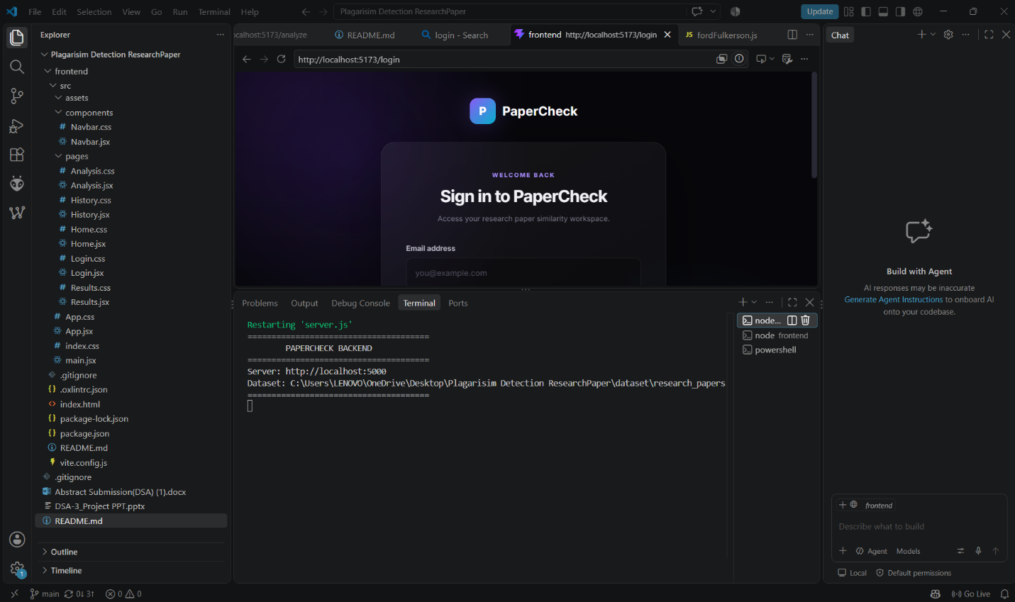
The login page provides a user interface for accessing the PaperCheck application. It contains email and password fields and a Sign In button.
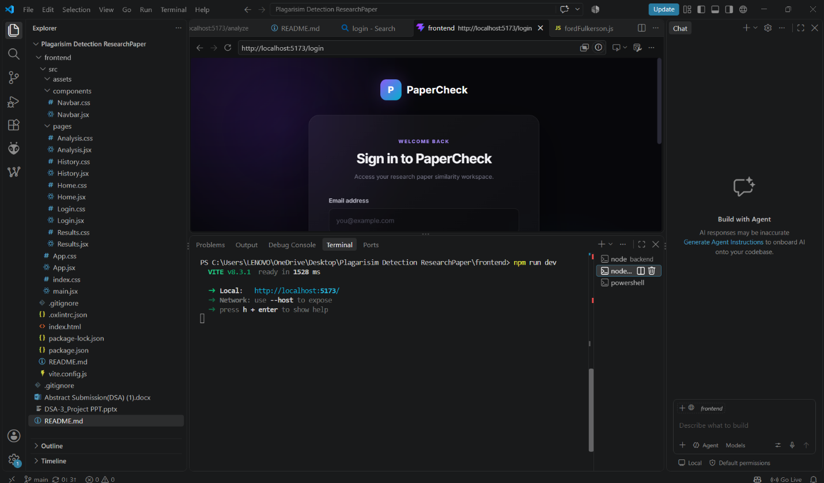
The home page introduces the research-paper similarity checking system and provides navigation to the paper analysis and history sections. It allows users to begin checking their research papers.
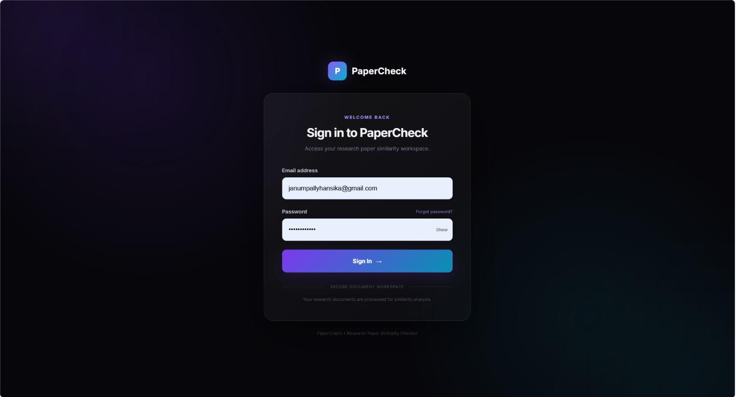
The upload page allows users to select or drag and drop a PDF file for analysis. The application supports PDF uploads with a displayed maximum file size of 50 MB.

The results page displays the overall similarity score, number of words analyzed, number of reference documents checked, and matching segments. In the shown execution, the system reports 12.22% similarity, 3,300 words analyzed, 100 documents checked, and 13 matching segments.

The similar-documents section lists reference papers identified during the analysis and displays their corresponding similarity values. This helps users identify documents that may contain matching text.


The backend terminal shows that the PaperCheck server is running at http://localhost:5000. It also displays the configured path of the reference research-paper dataset.
7.8 Discussion
The PaperCheck project demonstrates how Data Structures and Algorithms can be applied to develop a web-based research-paper similarity detection system. It automates the process of comparing an uploaded research paper with a collection of reference documents, reducing the need for manual text comparison.
The system uses Rolling Hash and Rabin–Karp algorithms as its core techniques for identifying matching text sequences. The uploaded PDF is processed through text extraction and preprocessing before the matching process begins. The backend then generates similarity information and returns the results to the frontend for display.
The project integrates several technologies, including React and Vite for the user interface, Node.js and Express.js for backend processing, Multer for file uploads, and pdf-parse for PDF text extraction. Its modular structure also supports the implementation and independent testing of additional DSA algorithms.
The application provides a simple workflow consisting of login, document upload, analysis, results, and history. The results interface presents the overall similarity value, the number of words analyzed, the number of reference documents checked, and details of similar documents.
In the displayed execution, the system reports 12.22% similarity, analyzes 3,300 words, checks 100 reference documents, and identifies 13 matching segments. These values illustrate the output produced for that particular document; they do not establish the overall accuracy of the system.
One limitation is that the results depend on the available reference dataset and the quality of PDF text extraction. Exact matching techniques may also fail to identify some paraphrased content. Furthermore, textual similarity does not automatically indicate plagiarism, since common terminology, quotations, and properly cited material may also produce matches.
Overall, PaperCheck provides a practical demonstration of algorithm-based document comparison and full-stack web development. Future improvements could include OCR support for scanned PDFs, matching-passage highlighting, more comprehensive accuracy evaluation, and improved similarity analysis.

- CONCLUSION & FUTURE SCOPE
8.1 Conclusion
The PaperCheck project, titled “Plagiarism Detection System Using Rolling Hash Techniques,” was developed to identify possible textual similarities between an uploaded research paper and a collection of reference documents. The project demonstrates the practical application of Data Structures and Algorithms in solving a real-world academic problem.
The system provides a web-based interface for uploading PDF documents and viewing similarity analysis results. It uses PDF text extraction and preprocessing to prepare the document for comparison. Rolling Hash and Rabin–Karp form the core matching techniques used to identify candidate matching text sequences.
The application integrates React and Vite for the frontend and Node.js and Express.js for the backend. It also includes additional algorithm implementations for demonstrating concepts related to hashing, dynamic programming, graph algorithms, optimization, and randomized algorithms.
The project achieves its main goal of providing an automated document-comparison workflow and displaying matching information in a user-friendly format. The results help users identify potential textual overlap and review the corresponding reference documents. However, the reported similarity value should be treated as an indicator of textual overlap rather than conclusive proof of plagiarism.
Overall, PaperCheck provides practical experience in algorithm implementation, full-stack web development, PDF processing, software testing, and modular system design.

8.2 Future Scope
The project can be improved through the following enhancements.
8.2.1 Short-Term Enhancements
- Improve error handling for invalid, corrupted, and unsupported PDF files.
- Optimize the processing of reference documents.
- Improve the presentation of matching results.
- Add clearer explanations of how similarity values are calculated.
8.2.2 Medium-Term Enhancements
- Integrate Optical Character Recognition (OCR) to process scanned research papers.
- Highlight matching passages in uploaded and reference documents.
- Store analysis history in a database.
- Add secure user authentication and access control.
- Evaluate the system using labelled documents and calculate precision, recall, and F1-score.
8.2.3 Long-Term Enhancements
- Integrate semantic similarity techniques to identify potentially related passages with different wording.
- Develop a larger and regularly maintained reference-paper collection.
- Introduce indexed fingerprint storage to improve performance on larger datasets.
- Generate downloadable similarity reports.
- Deploy the application on a secure hosting platform for wider academic use.
8.3 Final Remarks
PaperCheck establishes a foundation for automated research-paper comparison using hashing and pattern-matching techniques. With further improvements in accuracy evaluation, document processing, performance, and result interpretation, the system could become a more comprehensive tool for supporting academic integrity.

- REFERENCES

1. 1. Cormen, T. H., Leiserson, C. E., Rivest, R. L., and Stein, C. Introduction to Algorithms. 4th Edition, MIT Press, 2022.
2. Karp, R. M., and Rabin, M. O. “Efficient Randomized Pattern-Matching Algorithms.” IBM Journal of Research and Development, Vol. 31, No. 2, pp. 249–260, 1987.
3. Levenshtein, V. I. “Binary Codes Capable of Correcting Deletions, Insertions, and Reversals.” Soviet Physics Doklady, Vol. 10, pp. 707–710, 1966.
4. Needleman, S. B., and Wunsch, C. D. “A General Method Applicable to the Search for Similarities in the Amino Acid Sequence of Two Proteins.” Journal of Molecular Biology, Vol. 48, No. 3, pp. 443–453, 1970.
5. Smith, T. F., and Waterman, M. S. “Identification of Common Molecular Subsequences.” Journal of Molecular Biology, Vol. 147, No. 1, pp. 195–197, 1981.
6. Manning, C. D., Raghavan, P., and Schütze, H. Introduction to Information Retrieval. Cambridge University Press, 2008.
7. Node.js Documentation. Node.js JavaScript Runtime. Available at: https://nodejs.org/docs/
8. React Documentation. React: The Library for Web and Native User Interfaces. Available at: https://react.dev/
9. Express.js Documentation. Express Web Framework for Node.js. Available at: https://expressjs.com/
10. Vite Documentation. Next Generation Frontend Tooling. Available at: https://vite.dev/

